**IMPLEMENTATION OF MULTITHREADED PROGRAMS**

**AIM:**

Write a java program to implement Multithreaded programs.

**PROGRAM**:

/**

*

* @author 2162014

*/

import java.util.Random;

public class th {

public static void main(String[] args) {

Random random = new Random();

NumberGenerator numberGenerator = new NumberGenerator(random);

SquareCalculator squareCalculator = new SquareCalculator();

CubeCalculator cubeCalculator = new CubeCalculator();

Thread generatorThread = new Thread(numberGenerator);

Thread squareThread = new Thread(squareCalculator);

Thread cubeThread = new Thread(cubeCalculator);

generatorThread.start();

squareThread.start();

cubeThread.start();

}

}

class NumberGenerator implements Runnable {

private final Random random;

public NumberGenerator(Random random) {

this.random = random;

}

@Override

public void run() {

while (true) {

int number = random.nextInt(10);

if (number % 2 == 0) {

SquareCalculator.handleNumber(number);

} else {

CubeCalculator.handleNumber(number);

}

try {

Thread.sleep(1000);

} catch (InterruptedException e) {

e.printStackTrace();

}

}

}

}

class SquareCalculator implements Runnable {

public static synchronized void handleNumber(int number) {

System.out.println("Received an even number: " + number);

int square = number * number;

System.out.println("Square of the number: " + square);

}

@Override

public void run() {

// This thread doesn't need to do anything, as the handleNumber() method

// is static and synchronized, so it can be called from any thread.

}

}

class CubeCalculator implements Runnable {

public static synchronized void handleNumber(int number) {

System.out.println("Received an odd number: " + number);

int cube = number * number * number;

System.out.println("Cube of the number: " + cube);

}

@Override

public void run() {

// This thread doesn't need to do anything, as the handleNumber() method

// is static and synchronized, so it can be called from any thread.

}

}

**OUTPUTS**:

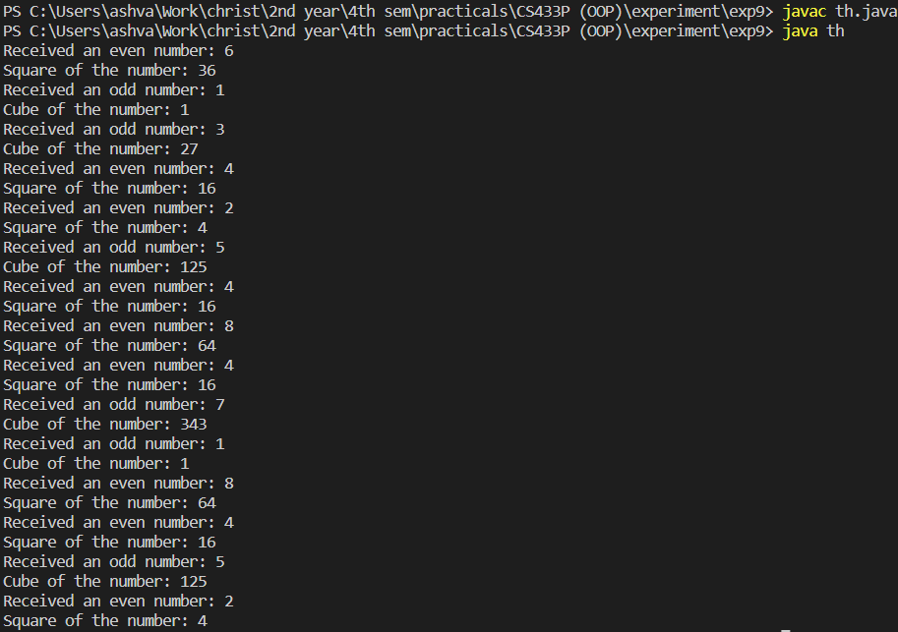

**RESULTS:**

The java program was created successfully implements Multithreaded programs.